

Software engineering homework

Collage： | 华南理工大学
Major：
Student name： | 喻琰 资琛义
Student number： | 201930330254 201936234280
Instructor： | 李剑
Course number：
Course credit：

Report
  - use case diagram
show the monitoring system’s functions and how it interacts with external entities
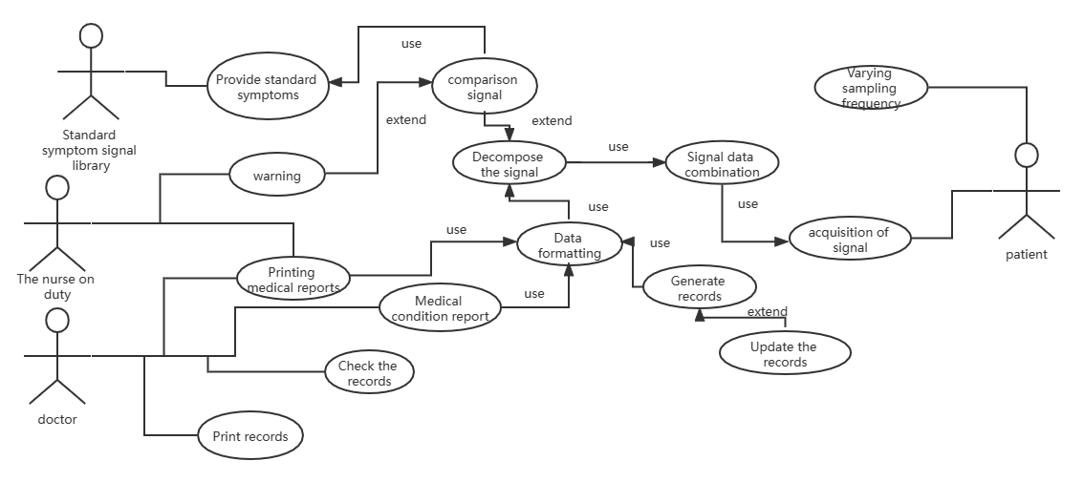
1-2packages
identify the principal sub-systems and the links between them
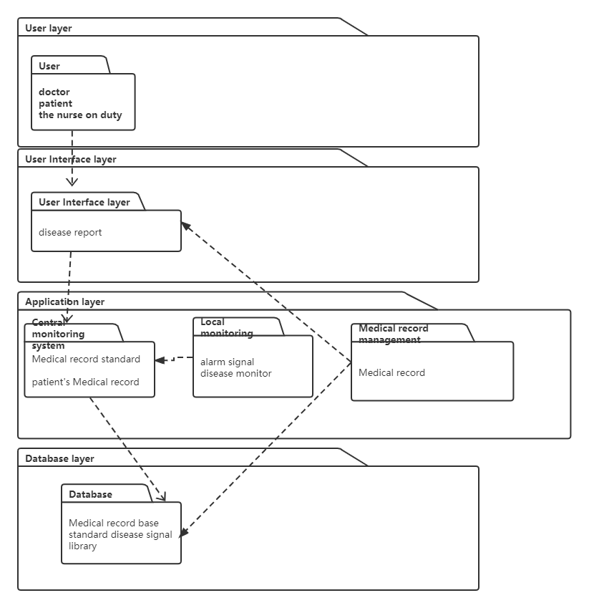
1-3 sequence diagram
To show the process of Monitoring
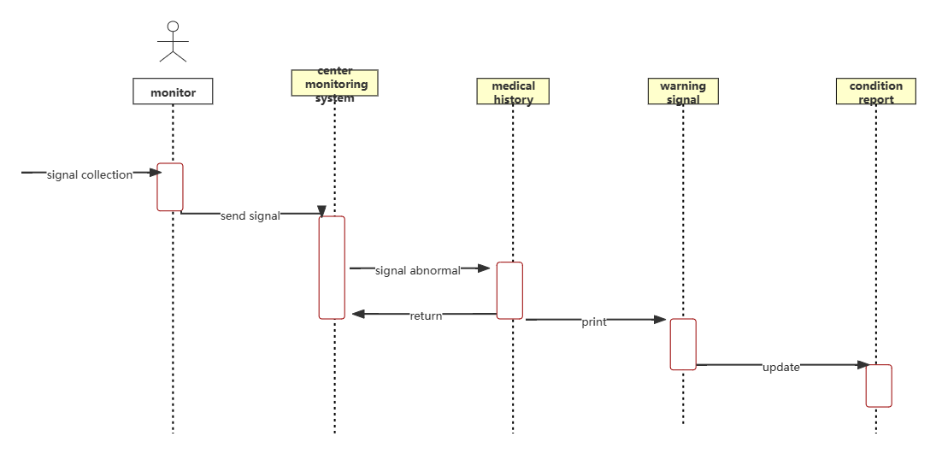
1-4 state machine diagram
show the states and state transitions of monitoring system

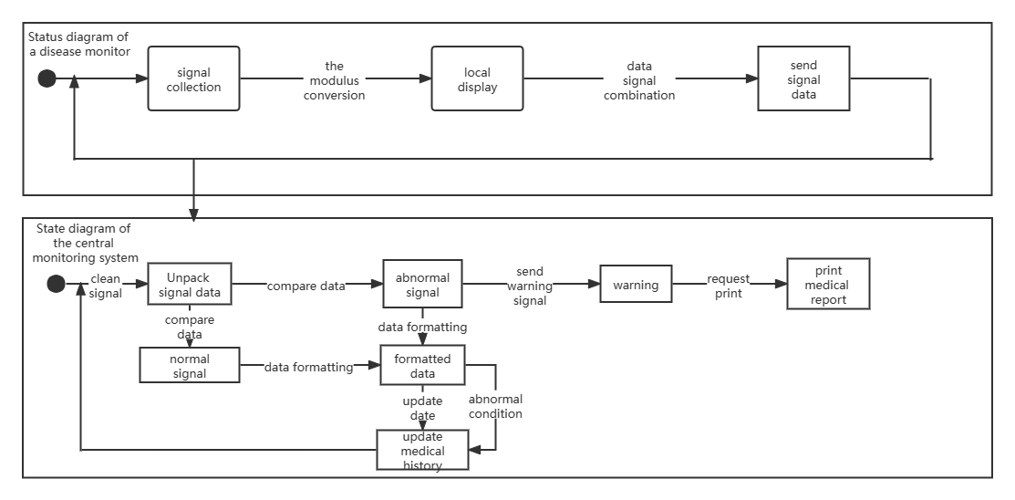
  - class diagram
Identify the main classes in the monitoring system
Identify the relationships between classes
